# Project report template

# 1.INTRODUCTION:

1.1 overview

An application tracking system (ATS) is software for recuiters and employers to track candidates throughout the recruiting and hiring process Every organization is unique,but each one thrives on attracting,hiring,maximizing top talent.many businesses face major challenges at some point in the hiring or onboarding process.

2.problem definition and design thinking:

2.1 Empathy map

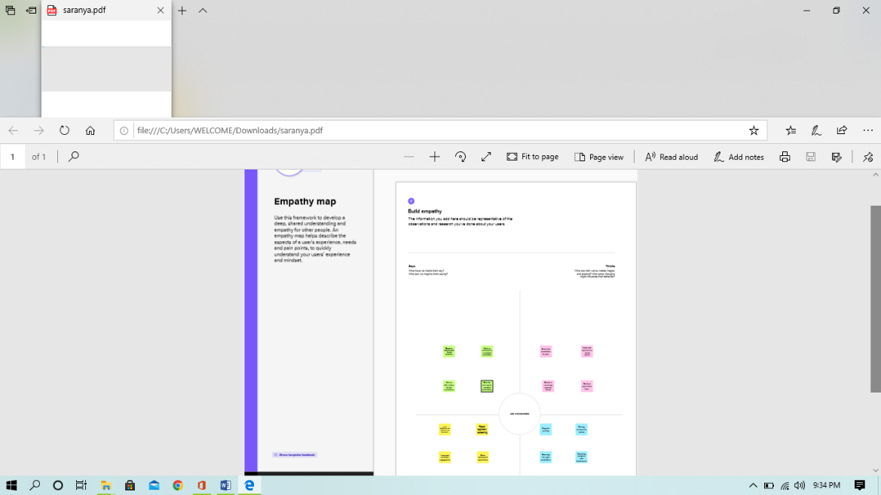

2.2 Ideation and brainstroming map

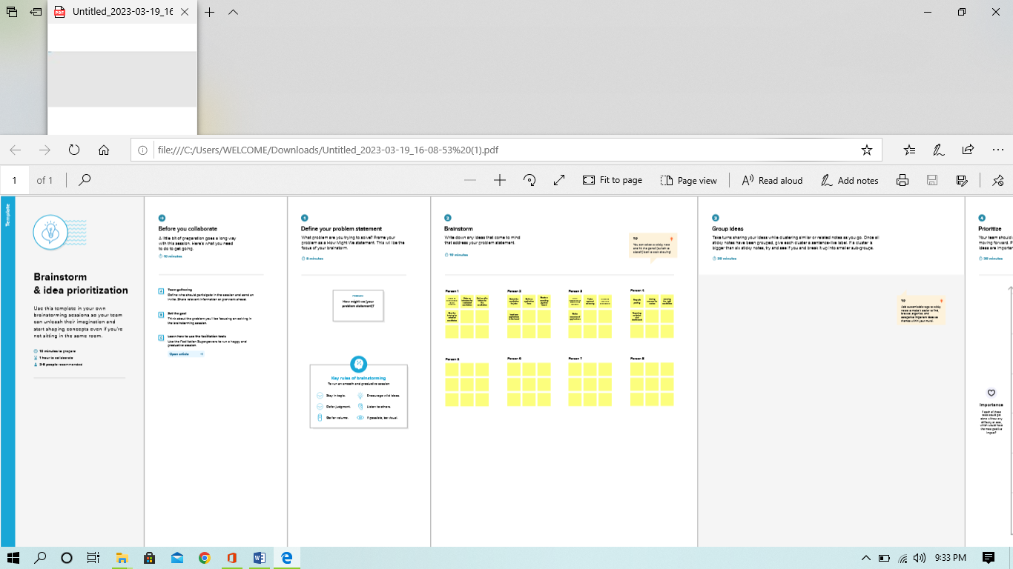

3.RESULT

3.1 Data model:

|  |  |
| --- | --- |
| Object name | Fields in the object |
| Obj 1 | |  |  | | --- | --- | | Field label | data type | | Look up field | Text area | |  |  | |
| Obj 2 | |  |  | | --- | --- | | Field lable | Data type | | Field name | |

3.2 activity and screen shot

Milestone 1

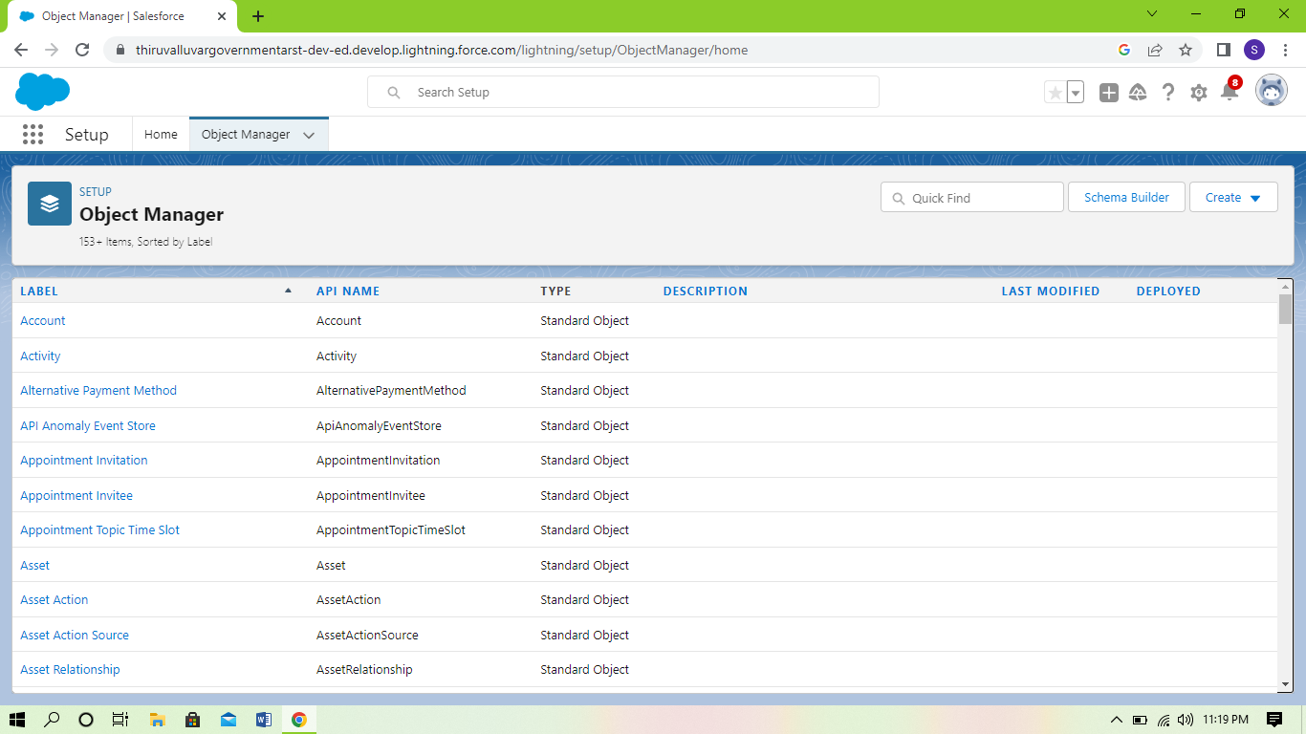

Milestone 2

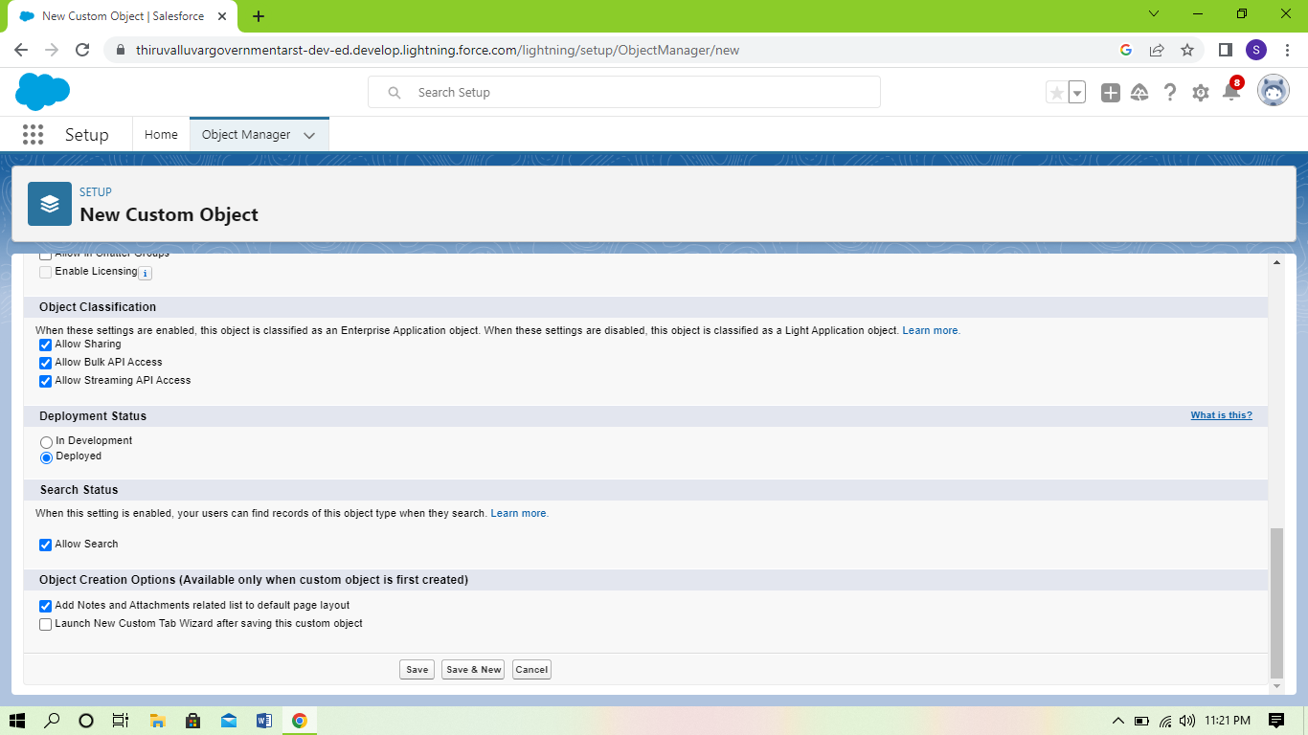

Milestone 3

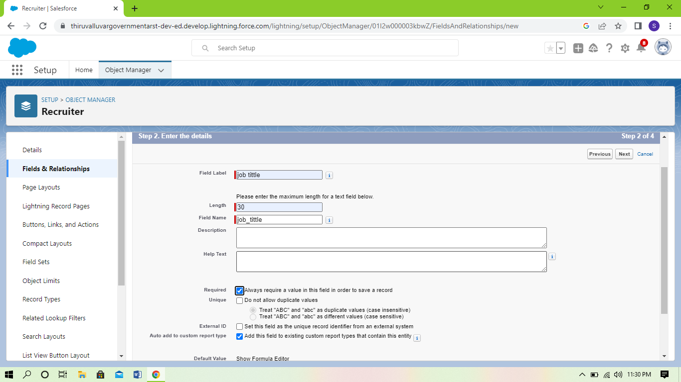

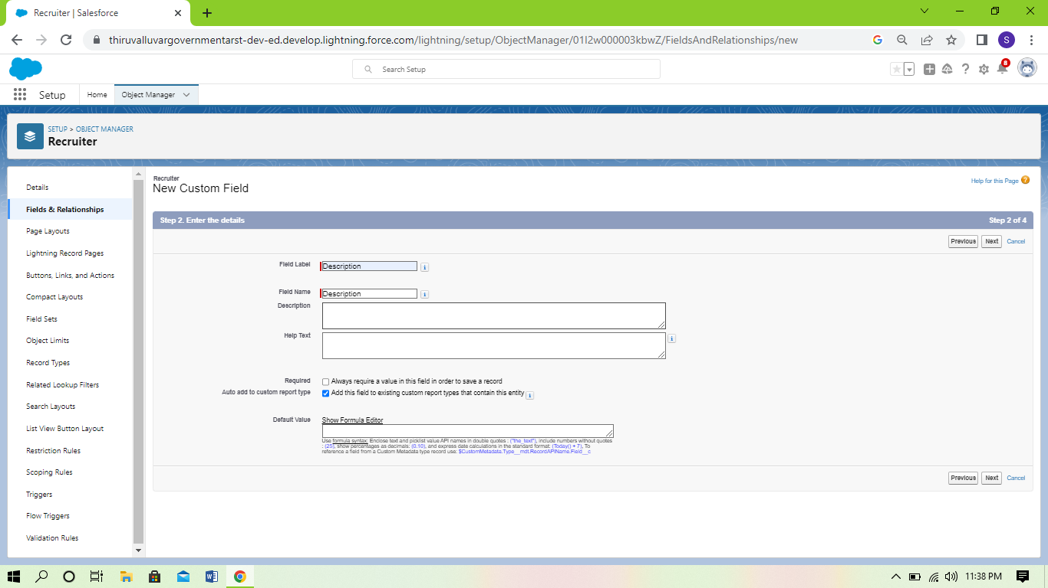

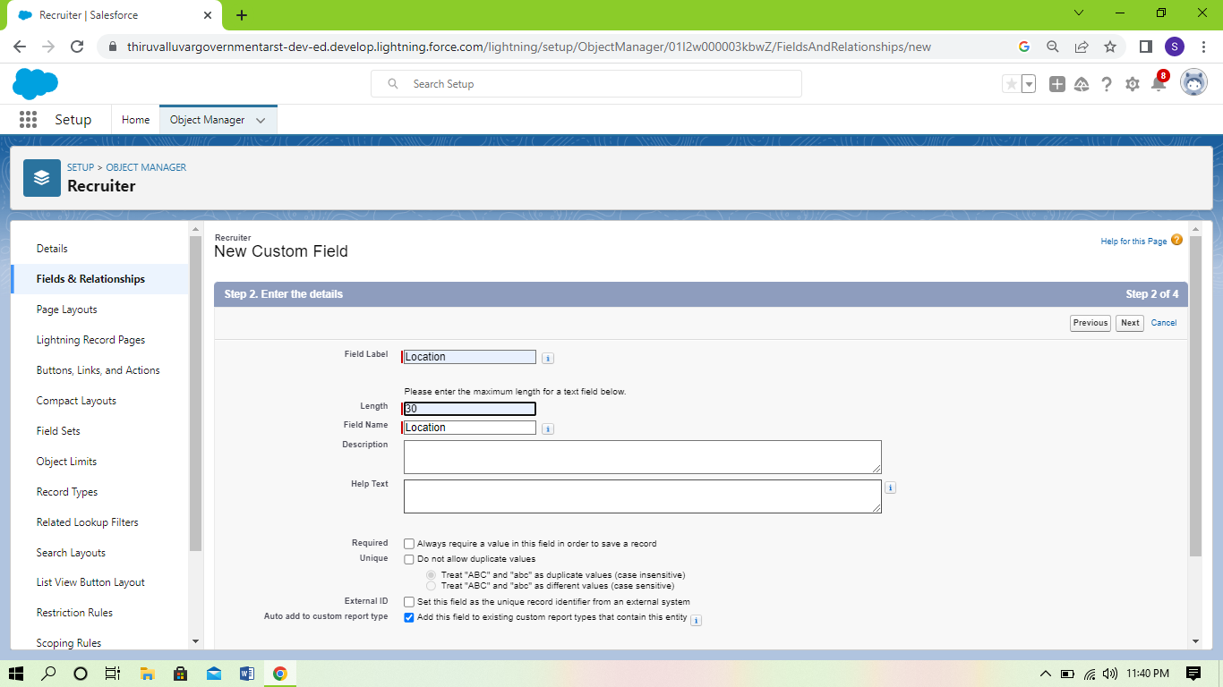

Milestone 4

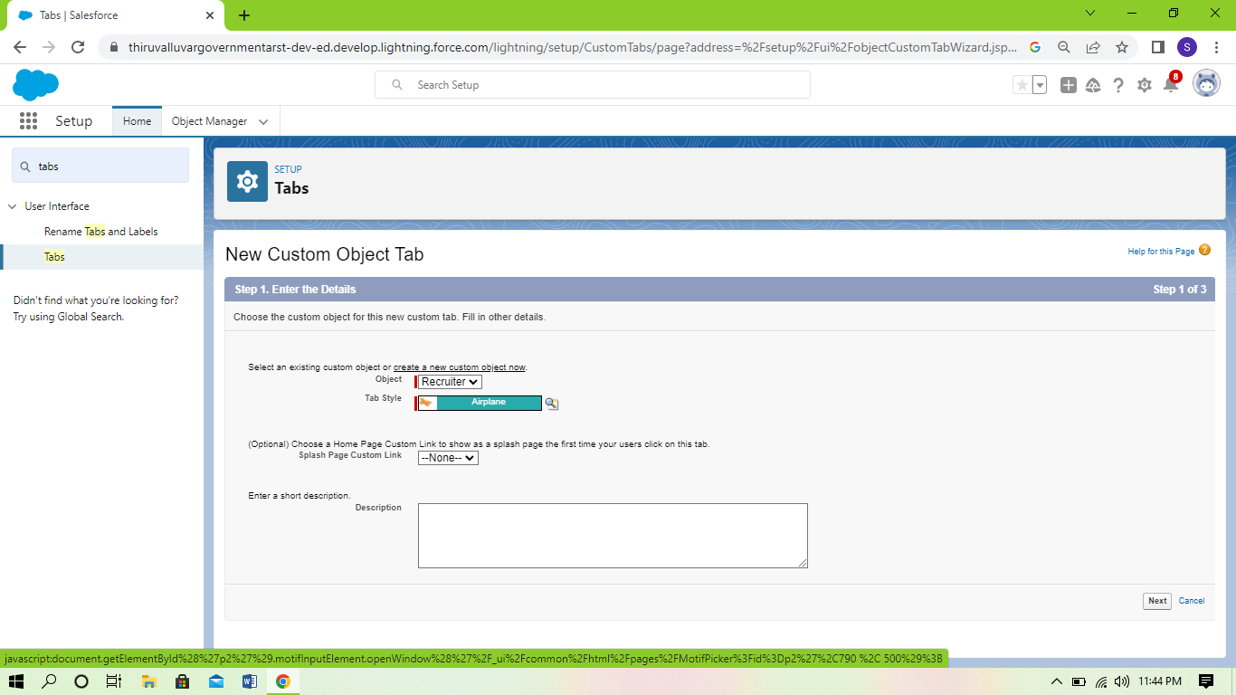

Milestone 5

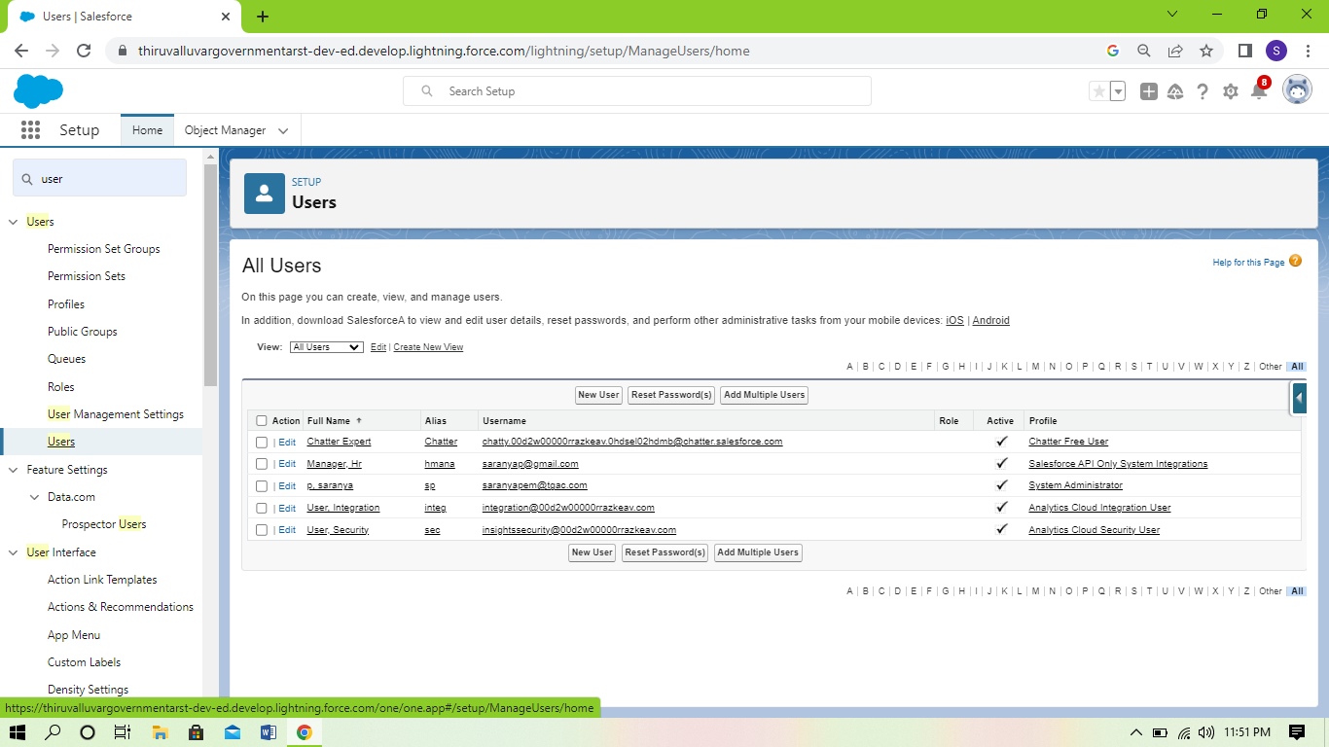

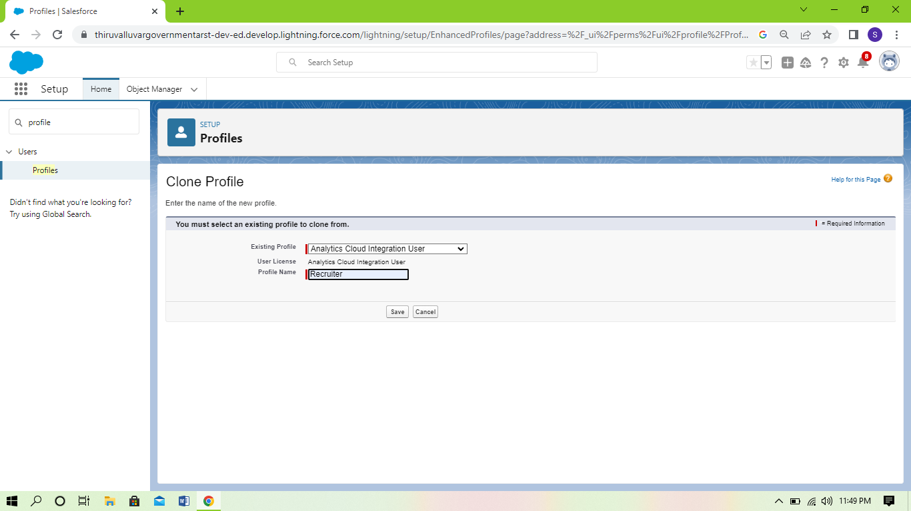

Milestone 6



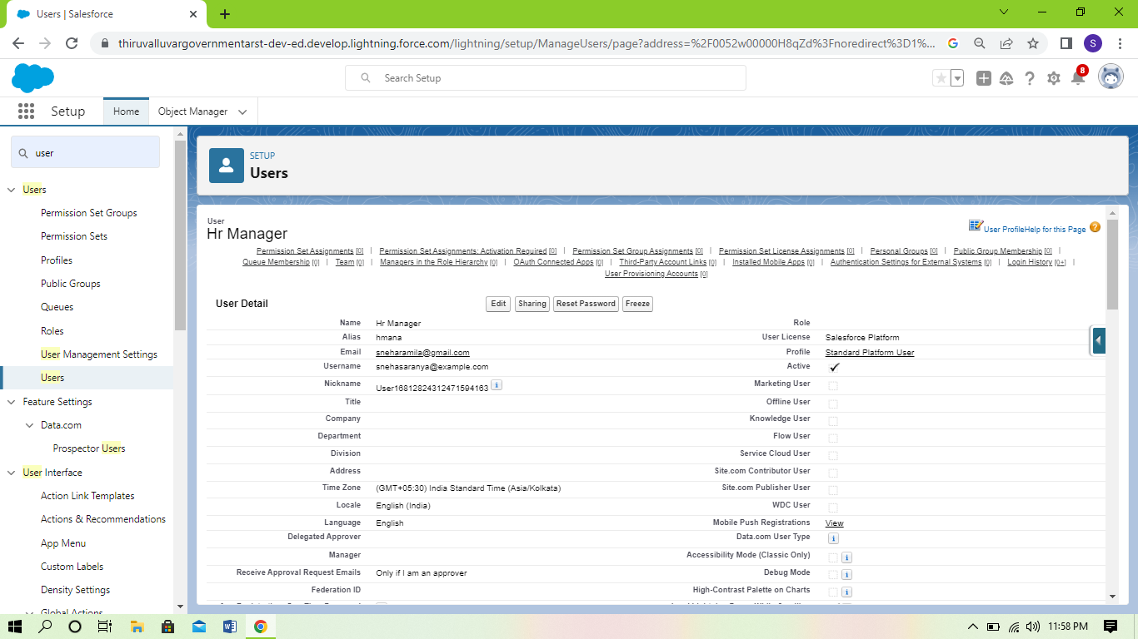

4. trailhead profile public URL

Team Lead - <https://trailblazer.me/id/sphysicsem>

Team Member 1 – <https://trailblazer.me/id/sphyem1>

Team Member 2 - <https://trailblazer.me/id/mwari22>

Team Member 3- [trailblazer.me/id/nphysicsem](https://trailblazer.me/id/nphysicsem)

ADVANTAGES AND DISADVANTAGES:

ADVANTAGES:

Reduce time spend on admin tasks .ATS software allows you to automate various tasks of the hiring process that can save you a lot of time and free up your recruiting personal for other high _value tasks. Posting to multiple job boards,tracking candidate applications,notifing candidate individually,and scheduling interview feedback can all be automated .

DISADVANTAGES:

Communications can be less personalised.when automating responses to candidates ,your messaging will be less pesonalised and can come off as robotic.

6. APPLICATIONS:

An applicant tracking system (ATS) is software that manages the recruiting and hiring process,including job postings and job applications .it organizes information about job seekers and makes it searchable .As its name implise,an ATS tracks candidates through the hiring process.

7. CONCLUSION

Project management helps to detail what tasks will be accomplised,who will be involved in completing the tasks,and when tasks should start and finish .

8. FUTURE SCOPE:

An applicant tracking system (ATS) is software for recruiters and employers to track candidates throughout the recruiting and hiring process.